Adsorption of a C₆₀ fullerene molecule on a defective Al(100) surface
Mohinur Choriyeva^{1,*)}, Ikrom Urolov^{1,2)}, Ishmumin Yadgarov¹⁾
¹Institute of Ion-plasma and laser technologies, 100125, 33 Durmon yuli street, Uzbekistan*chorievamohinur667@gmail.com
Currently, numerous studies on the interaction of fullerene C60 molecules with various metal surfaces, and their adsorption processes, have been at the center of attention of leading scientists in fields such as nanotechnology, materials science, and energy. In particular, composites consisting of aluminum and C60 molecules as matrix and filler, respectively, have emerged as leaders in energy storage and the automotive industry.In this study, the adsorption of fullerene C60 molecules on a defective aluminum Al(100) surface was simulated using the MD method in the open-source LAMMPS package. During the study, the adsorption energy was calculated and found to be E_ads = 3.20 eV.
This value was observed when the fullerene molecule approached a surface with a single defect in a pentagon configuration. The resulting Al–C bond lengths were measured. The interaction processes were modeled using the Tersoff interatomic potential, which effectively describes interatomic forces and structural properties in systems with covalent bonding [1]. The adsorption process was carried out at 0 K, and to maintain this temperature, the Nosé–Hoover thermostat in the NVT ensemble was employed.Based on the obtained results, the following conclusion was drawn: when the fullerene C60 molecule adsorbs on the substrate surface in a pentagon configuration, this process corresponds to chemisorption. Furthermore, it was found that the average length of the resulting Al–C bonds in this interaction is λ = 2.26 Å.
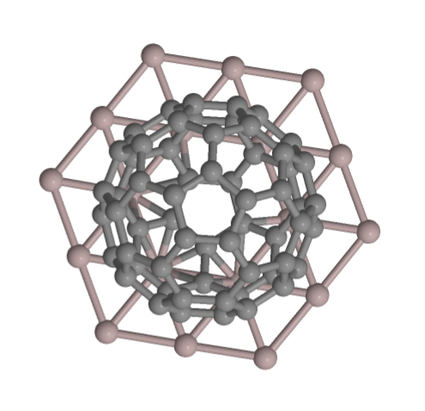Figure 1 a) Adsorption of C60 fullerene on a defective Al(100) surface.

Figure 1 a) Fullerene molecule adsorbed on the (001) surface of the substrate.

[1]. Kaiser, A., Viñes, F., Illas, F., Ritter, M., Hagelberg, F. & Probst, M. (2014). Vacancy patterning and patterning vacancies: Controlled self-assembly of fullerenes on metal surfaces. Nanoscale, 6(18), 10850–10858. https://doi.org/10.1039/C4NR02717E

