Computer Simulation of the Interaction Between an Iron Substrate and a C60 Fullerene Molecule
Muazzamxon Mamadaliyeva^{1,*,}, Ikrom Urolov¹, Ishmumin Yadgarov¹
Institute of Ion-Plasma and Laser Technologies named after U.A. Arifov, 33 Do‘rmon yo‘li, Tashkent 100125, Uzbekistan
* muazzamxon.zubayr@gmail.com
Due to the rapid development of science and technology, the interaction between iron surfaces and carbon nanostructures has gained significant scientific importance in modern materials science and nanotechnology. In particular, the adsorption of Fullerene C60 molecules on an iron (Fe) surface and the associated charge transfer processes can substantially influence the physical, chemical, and magnetic properties of the surface. Understanding the mechanisms of this interaction provides an essential theoretical foundation for applications in catalysis, protective coatings, and nanoscale device fabrication.
In this study, the adsorption of a C60 fullerene molecule on the Fe (110) surface was simulated using the molecular dynamics (MD) method implemented in the open-source LAMMPS software package. The interatomic interactions between Fe–Fe, C–C, and Fe–C atoms in the iron substrate and the fullerene molecule were described using the second-generation Tersoff/ZBL potential. The adsorption process was carried out at a temperature of 0 K. To maintain temperature stability, the Nose–Hoover thermostat within the NVT ensemble was applied.
The obtained results indicate that the adsorption of the Fullerene C60 molecule on the iron substrate surface is stable, with an adsorption energy of Eₐds = 0.4 eV, suggesting a chemisorption mechanism.Furthermore, it was determined that the average bond length of the newly formed Fe–C bonds during the interaction process is λ = 2.41 Å.  . | 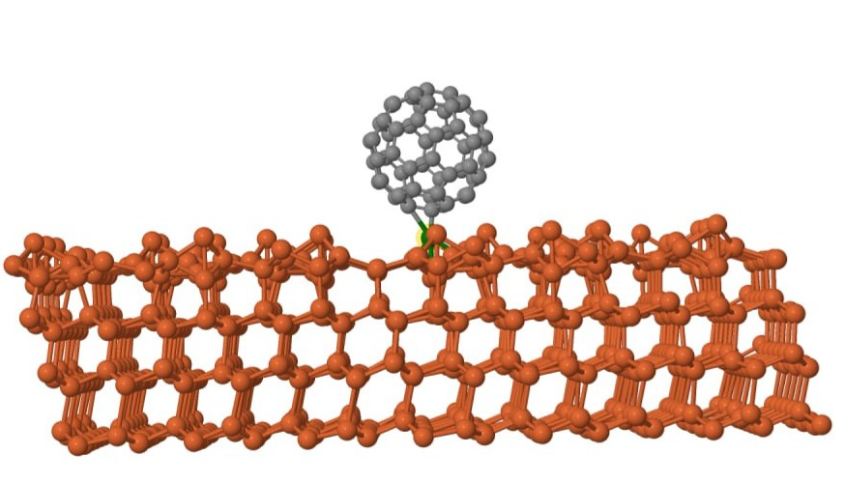

References
1.J. Tersoff, “Modeling Solid-State Chemistry: Interatomic Potentials for Multicomponent Systems,” Physical Review B, 39, 5566–5568 (1989).
2.F. H. Stillinger and T. A. Weber, “Computer Simulation of Local Order in Condensed Phases of Silicon,” Physical Review B, 31, 5262–5271 (1985).

