MOLECULAR MECHANISMS AND STRUCTURAL EVOLUTION IN LASER-INDUCED GRAPHENE FORMATION
Tursunpulat Juraboev^{1*)}, Umedjon Khalilov^{1,2)}
¹⁾ Arifov Institute of Ion‐Plasma and Laser Technologies, Tashkent, Uzbekistan
²⁾ University of Antwerp, Antwerp, Belgium
^{*)}e-mail: tursunpulatjuraboev24@gmail.com

Although laser-induced graphene (LIG) synthesized from polymer precursors has attracted significant attention due to its simplicity and versatility, the atomistic mechanisms governing its formation remain insufficiently understood [1]. In this work, the formation stages of LIG on Kapton polyimide were investigated using reactive molecular dynamics (MD) simulations based on an extended C/H/O/N ReaxFF force field [2]. The simulations allow us to capture both the thermal decomposition of the polymer matrix and the subsequent carbon reorganization processes at elevated temperatures.
The results reveal that during the heating stage up to 6000 K, intensive bond scission in the polymer backbone leads to the desorption of small gaseous species, predominantly CO, H₂, and C₂H₂. Subsequent cooling of the plasma-like carbon system initiates the nucleation of sp²-hybridized carbon structures, including hexagonal, pentagonal, and heptagonal rings, indicating the early-stage formation of graphene-like domains.

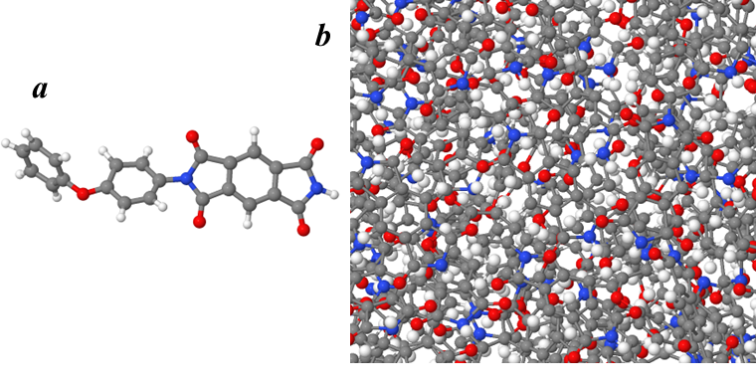
Figure 1. (a) Chemical structure of the Kapton polyimide monomer selected as the building unit; (b) Atomistic model of the initial simulation system before thermal treatment.

REFERENCES
[1] J. Lin, and at.all, Nat Commun 5, 5714 (2014).
[2] M. Kowalik and at.all, J Phys Chem B 123, 5357 (2019).

