Fast-forward cooling dynamics of nanosystems

Mamanazarov M.T1.

1Academy of science of Uzbekistan, Institute of Ion-Plasma and Laser Technologies, Durmon yuli 33, Tashkent , Uzbekistan.

We address the issue of energy measurement for accelerating the development of many-body quantum systems utilizing Masuda-Nakamura’s fast forward theory. Our work shows that they can use more knowledge about the Hamiltonian and possibly quantum computational techniques such as fast forwarding or others to go beyond the Heisenberg limit.

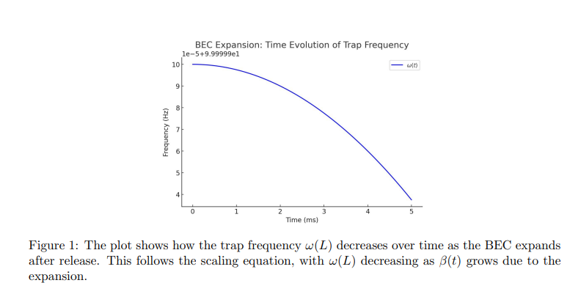

In this paper we shall firstly show fast cooling can be done by modifying the trap frequency ω(t) in optimized way. Instead of a slow adiabatic expansion, the trap is opened rapidly with engineered path for ω(t), avoiding excitations. Our framework can be optical dipole traps use time-dependent laser intensities to archive this controlled expansion.

We have solved **β(t)i = ω2i (0) / β i ∑ Pj βj** with **β(t) = √1 + ω2 (0)t**

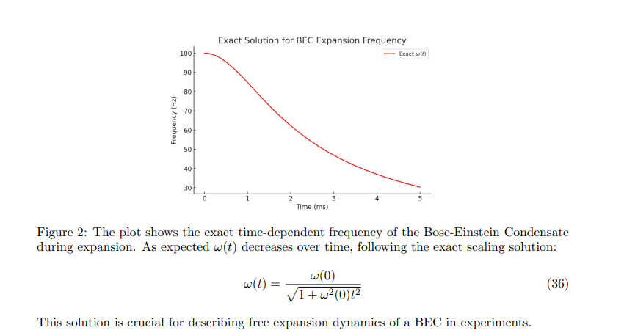

Adabiyotlar:

1. S. Masuda and K. Nakamura, Phys. Rev. A 78, 062108 (2008).

2. I.Setiawan1, R.Sugihakim, B.E.Gunara, S.Masuda, and K.Nakamura, Nat. Prog. Theor. Exp. Phys.063A04, 397 (2023)