A NUCLEATION MECHANISM OF ZINC-BASED MOF STRUCTURES

Aziza.Ergasheva1 and Umedjon Khalilov1,2

1) Institute of Ion-Plasma and Laser Technologies, Tashkent, Uzbekistan

2) University of Antwerp, Antwerp, Belgium

*) azizaabdujabborqizi@gmail.com

Metal-organic frameworks (MOFs) are of interest due to their high porosity and are used in catalysis, gas separation, and biology [1–4]. Although numerous experimental studies have been conducted on MOF synthesis, the nucleation mechanism has not been sufficiently investigated. Therefore, in this study, we explore the nucleation processes of IRMOF-1 using reactive Molecular Dynamics simulations. The preliminary results indicated that the selected ligand (1,4-benzodicarboxylate) and the metal node (Zn₄O) preferentially combine, forming the IRMOF-1 unit cell (Fig. 1).

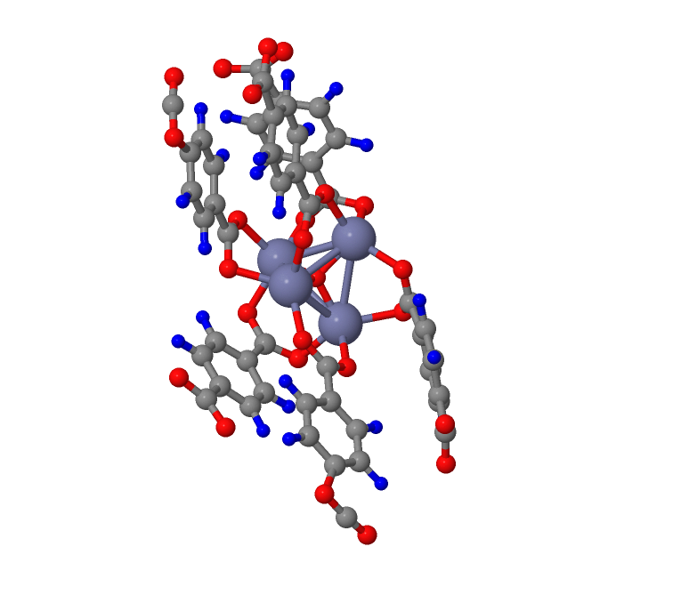Figure 1. Nucleation of Mono IRMOF-1 based on Zn4O and 1-4-benzodicarboxylate

This study provides new insights into the early synthesis stages of zinc-based IRMOFs.

REFERENCES

[1] O. M. Yaghi et al, Nature **423**, 705 (2003).

[2] Z. Lei et al., Advanced Energy Materials **8**, 1801587 (2018).

[3] X. Zhang et al., Electrochem. Energ. Rev. **2**, 29 (2019).

[4] Y. Deng et al., Biomater. Sci. **12**, 3725 (2024).