COMPUTER MODELING OF THE INTERACTION PROCESS OF THE FULLERENE C60 MOLECULE WITH THE SURFACE OF AN ALUMINUM SUBSTRATE

Mohinur Choriyeva1), Ikrom Urolov1,2), Ishmumin Yadgarov1,\*)

1)Institute of Ion-plasma and laser technologies, 100125, 33 Durmon yuli street, Uzbekistan

2)National University of Uzbekistan named after Mirzo Ulugbek, Tashkent 100174, Uzbekistan.

\*)e-mail: [ishmuminyadgarov@gmail.com](mailto:ishmuminyadgarov@gmail.com)

In this research, the adsorption of fullerene C60 molecule on aluminum Al(001) surface was simulated in the open source LAMMPS package based on the molecular dynamics method. The results were obtained by expressing the $Al-Al$, $C-C$ and $Al-C$ interactions between the aluminum substrate and the atoms constituting the fullerene molecule using the second-order interatomic potential Tersoff potential [1]. The aluminum substrate on which the adsorption of fullerene C60 molecule was observed consists of a cubic single crystal with a size of 18.34×18.34×18.34 Å and has 500 atoms. The adsorption energy of the fullerene molecule on the substrate surface was determined by energy minimization.

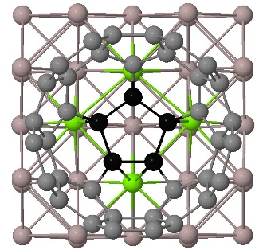

Figure 1 a) Fullerene molecule adsorbed on the (001) surface of the

substrate.

Figure 1 a) Fullerene molecule adsorbed on the (001) surface of the substrate.

The results obtained show that the adsorption of the fullerene C60 molecule with a pentagonal configuration on the substrate surface is stable and consists of chemical adsorption with an energy of $E_{ads}=3.10$ $eV$. It was also found that the average length of the $Al-C$ bonds formed during this interaction is equal to $λ = 2.46 Å$.

REFERENCE

1. G. Plummer and G.J. Tucker, Physical review B, Vol. 100, pp. 214114, 2019.