MEASUREMENT OF THE YIELD OF CHARACTERISTIC X-RAY RADIATION GENERATED BY 1–5 GeV ELECTRON BEAMS FROM THE UPSTREAM AND DOWNSTREAM SURFACES OF METAL FOIL

A.V. Shchagin1,2), R.M. Nazhmudinov2,3), A.S. Kubankin2,3), S.V. Trofymenko1,4), A.P. Potylitsyn5), A.S. Gogolev5), N.A. Filatov5),G. Kube6), N.A. Potylitsina-Kube6), M. Stanitzki6), R. Diener6), A. Novokshonov6)

1) Kharkiv Institute of Physics & Technology, Kharkiv, Ukraine

2) Belgorod National Research University, Belgorod, Russia

3) P.N. Lebedev Physical Institute, Moscow, Russia

4) Karazin Kharkiv National University, Kharkiv, Ukraine

5) Tomsk Polytechnic University, Tomsk, Russia

6) Deutsches Elektronen-Synchrotron, Hamburg, Germany

The results of measuring the ionization cross section of the Ti and Cu K-shells by electrons with energy of 1–5 GeV are presented. The yield of characteristic X-ray radiation (CXR) generated by electrons from "upstream" and "downstream" surfaces of 30 µm thick Ti and Cu foils was measured. The experiment was performed at Test Beam Facility (TB21) of DESY at beam current (1.7–6.7) × 103 e­–/s (Figure 1).

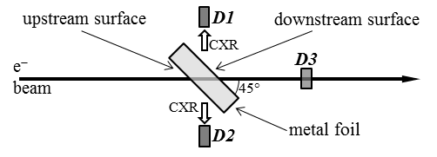

Figure 1 Measurement scheme

Semiconductor X-ray detectors *D1* and *D2* registered CXR spectra; semiconductor detector *D3* measured the number of electrons interacting with the target. The difference in the radiation yields from upstream and downstream surfaces of the targets is discussed.

The work was supported by AIDA within the European Union’s Horizon 2020 research and innovation program under grant agreement No 654168 and by a Program of the Ministry of Education and Science of the Russian Federation for higher education establishments, project No.FZWG-2020-0032 (2019-1569).